‘

Module 2 Assignment: Personal Philosophy of Nursing

Submit by 2359 (CT) Saturday at the end of Module 2.
NOTE: You will create a new Word document for this Assignment instead of typing directly into this document. This is the only time in the course you are asked to do this. All other assignments will be submitted on the template.
Overview: “Personal Philosophy of Nursing”
In this module’s Assignment, you will draft a formal paper expressing your personal philosophy of nursing paper. In this paper, you will provide a framework for your personal practice of nursing and reflect on why you chose nursing as a profession. Your paper will define how you interact with patients, family members, other nurses, and other health care professionals.
Since this is your first formal paper for the program, be sure to use the resources listed below to ensure you are using the proper APA formatting, title page, and scholarly language. The utilization of APA format adds structure, organization and professionalism to your writing. Correct APA format is expected throughout the RN-BSN program.
***Please scroll through this entire document to see the step by step requirements for the paper under “Content Criteria” table***

Resources
ANA Code of Ethics https://www.nursingworld.org/coe-view-only

APA Resources-
https://libguides.uta.edu/apa/home
https://owl.purdue.edu/owl/research_and_citation/apa_style/apa_formatting_and_style_guide/general_format.html
https://apastyle.apa.org/ (click APA Style Help)

https://www.youtube.com/watch?v=a_ddFubJ3tc (MS Word Tutorials for Beginners)
Review your course readings, lecture, and your Module 2 Resources before completing this module’s Assignment.
Performance Objectives
- Compose a personal philosophy of nursing.
- Correlate historical, ethical, and/or political factors influencing professional nursing
practice with what you believe the core of nursing is and should be.
- Apply professional practice standards.
- Use correct grammar, punctuation, and American Psychological Association (APA)
format in writing professional papers.
Rubric
Use this rubric and APA websites to guide your work on the Module 2 Assignment, “Personal Philosophy of Nursing.” Contact your Coach if you have questions.
Tasks  ⬇ | Accomplished | Proficient | Needs  Improvement
Personal Philosophy of Nursing Paper Format (Total 20 points) | Title Page  No mistakes in APA format  (10 points)  Writing Conventions  Professional grammar, spelling, and punctuation; paragraphs of at least 3, well-written sentences  (10 points) | Title Page  Errors in APA format  (5 points)  Writing Conventions  Paragraphs are 2 sentences each.  (8 points) | No Title Page  (0 points)  Writing Conventions  Answers are 1 sentence paragraph responses.  (5 points)

Tasks  ⬇ | Accomplished | Proficient | Needs  Improvement | Missing Information
Content (Total 60 points) | Introduction  Writes a comprehensive overview of the paper in 1-2 paragraphs.  (5 points)  Choice of Nursing  Clearly answers question in 2-3 paragraphs.  (10 points)  Essence of Nursing Clearly answers question in 2-3 paragraphs with citations for any information regarding history, ethical or political factors discussed. All 3 factors discussed for full credit.  (10 points)  Beliefs and Values  Answers each of the 4 questions in separate paragraphs.  (15 points)  Vision for the Future  Answers question for all 3 time periods listed in separate paragraphs.  (10 points)  Summary  Answers both questions in separate paragraphs.  (10 points) | Introduction  Writes an overview of the paper in 1-2 paragraphs.  (4 points)  Choice of Nursing  Answers question in 1 paragraph.  (8 points)  Essence of Nursing  Adequately answers question in 2-3 paragraphs with citations for any information regarding history, ethical or political factors discussed.  OR  Only answers 2 factors  OR  Answers all questions but in one paragraph.  (8 points)  Beliefs and Values  Answers 3 of the 4 questions in separate paragraphs  OR  Answers all questions but in one paragraph.  (12 points)  Vision for the Future  Answers question for 2 of the 3 time periods  OR  Answers all questions but in one paragraph.  (8 points)  Summary  Answers 1 question  OR  Answers both questions but in one paragraph.  (8 points) | No Introduction  (0 points)  Choice of Nursing  Does not answer question.  (0 points)  Essence of Nursing  Answers 1 of the 3 factors.  (5 points)  Beliefs and Values  Answers 1 or 2 of the 4 questions.  (5 points)  Vision for the Future  Answers 1 question of the 3 time periods.  (3 points)  Summary  Does not directly address either question.  (4 points) | Essence of Nursing  Does not answer question.  (0 points)  Beliefs and Values  Does not answer question.  (0 points)  Vision for the Future  Does not answer question.  (0 points)  Summary  No summary provided.  (0 points)
Tasks  ⬇ | Accomplished | Proficient | Needs  Improvement | Missing Information
APA format and References  (Total 20 points) | Uses correct APA format throughout paper and includes 2 correctly cited references. Correct spelling, grammar, punctuation, headings, spacing, indentations and margins.  (20 points) | 1-3 APA errors noted in references OR 1-2 citation errors within paper OR 1-3 grammar, spelling, punctuation, headings, spacing, indentation and margin errors noted in the entire paper.  (13 points) | 4-6 APA errors noted in references and citations throughout paper OR 1 reference listed OR 4 or more spelling, punctuation, headings, spacing, indentation and margin errors noted in the entire paper.  (6 points) | 7 or greater APA errors noted in references OR citations throughout paper OR no references listed OR 7 or greater spelling, punctuation, headings, spacing, indentation and margin errors noted in the entire paper.  (0 points)

Personal Philosophy of Nursing Paper
- Use the following outline to guide composition of your personal philosophy of nursing.
- Follow both the content and format criteria in completing your composition.
- Open a new Word document, and save it to your Desktop with the filename, “your name_Personal_Philosophy,” inserting your name in place of “your name.”
- Begin your paper by setting the margins, font, and Header. (See MS Word Help)
- Depending on your version of MS Word, there is assistance for APA Format under the Reference header as you are creating your paper. Choose APA 7th Edition. (See MS Word Help)
- Click “Save” often to keep from accidentally losing your work.
- Use the APA links provided above for all APA formatting in all assignments and discussion boards. Contact your Coach if you have additional questions.
Content Criteria
Section or Section Title | Description | How-To and Tips  Use
Entire paper | - 1” margins all around  - Double-spaced  Acceptable Fonts:  - 11-point Calibri  - 11-point Arial  - 10-point Lucida Sans Unicode  - 12-point Times New Roman  - 11-point Georgia  - 10-point Computer Modern 1  - Professional grammar, spelling, and punctuation, and paragraphs composed of at least 3 well-written sentences each. | - Select File – Page Setup…  - Select Format – Font…  - Select Format – Paragraph…  - Select View – Header and Footer...  (Refer to the MS Word “Help and How To” links if you need help with any of these tasks.)
Title Page | - The title page should contain the title of the paper (Bold), the student's name, and the institutional affiliation.  - Type your title in upper and lowercase letters centered in the upper half of the page. The title should be centered and written in boldface  - Your title may take up one or two lines  - A student paper should also include the course number and name, instructor name, and assignment due date.  - Use the “student” title page for your reference | https://owl.purdue.edu/owl/research_and_citation/apa_style/apa_formatting_and_style_guide/general_format.html  Example-  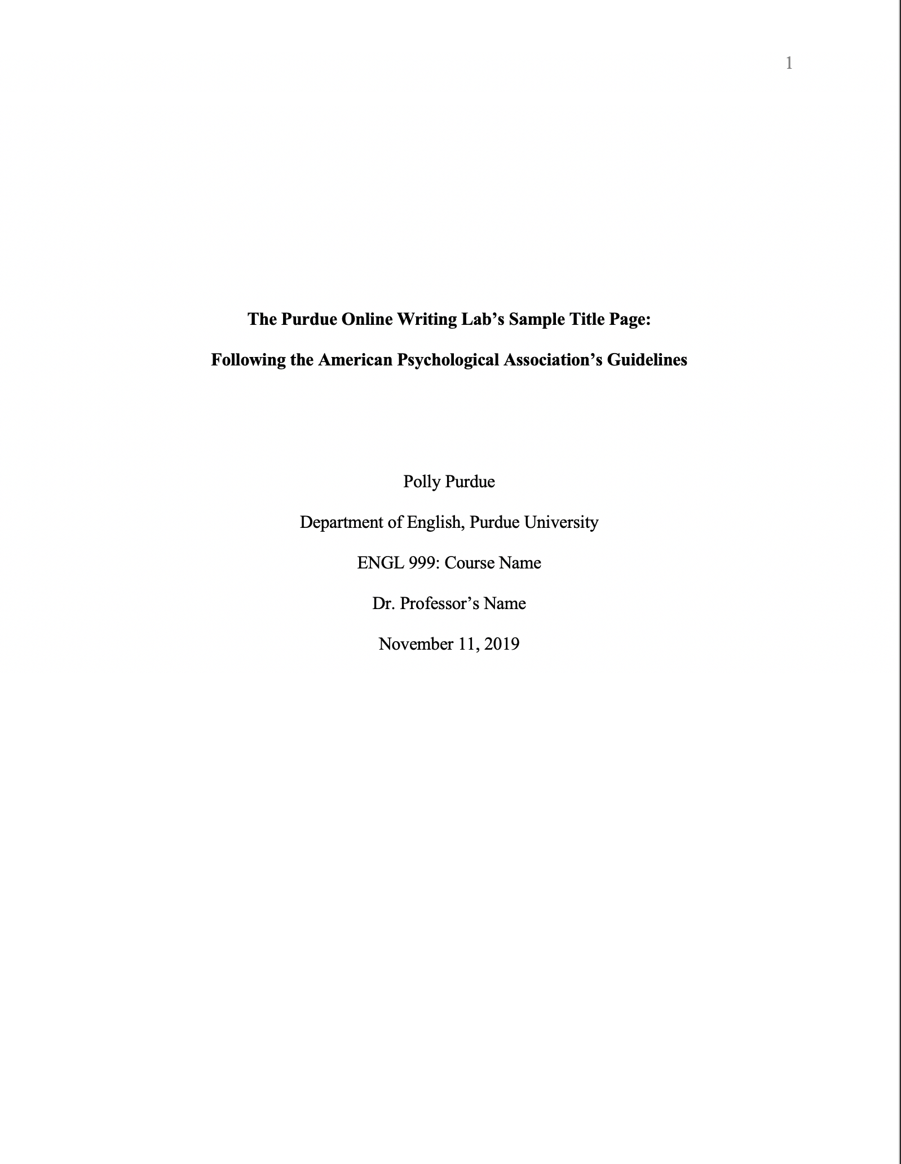
Introduction | Overview of the paper (1-2 paragraphs) *just a note, do not use an abstract, just type a formal introduction. | Put title of paper at the top of this page: centered, bold, and in Title Case.  No section title for the introduction, just start paragraphs (Remember to indent each paragraph and double space)
Choice of Nursing | Why did you choose nursing? (2-3 paragraphs) | Insert Section title, centered, bolded, and Title Case.  Then start paragraphs.
Essence of Nursing | What do you believe the core of nursing is and should be? Correlate historical, ethical, and political factors influencing professional nursing practice. You must answer all 3 factors for full credit (2-3 paragraphs) | Insert Section title, centered, bolded, and Title Case.  Then start paragraphs.  (Do not start a new page; just continue in regular double-spaced body.)
Beliefs and Values | What do you believe about patients? (1 paragraph)  What do you believe about the patient’s family and significant others? (1 paragraph)  What do you believe about your fellow health care providers?  (1 paragraph)  What do you believe about your own health? (1 paragraph) | Insert Section title, centered, bolded, and Title Case.  Then start paragraphs.  (Do not start a new page; just continue in regular double-spaced body.)
Vision for the Future | What do you want to be doing in 2 years? (1 paragraph) 5 years? (1 paragraph) 10 years? (1 paragraph) | Insert Section title, centered, bolded, and Title Case.  Then start paragraphs.  (Do not start a new page; just continue in regular double-spaced body.)
Summary | What strengths do you have that will support your achievement of your professional goals? (1 paragraph)  What limitations will you need to overcome to achieve your professional goals? (1 paragraph) | Insert Section title, centered, bolded, and Title Case.  Then start paragraphs.  (Do not start a new page; just continue in regular double-spaced body.)
References | References  centered on top of page  - At least 2 professional references.  - Put references in alphabetical order by author’s name. | “References” should be centered at the top of the page just below the header, bold.

- Save your assignment document in MS Word 2010 version and above. Open Office and Office 360 documents will need to be saved as MS Word 2010 or MS Word 2013.

- Submit your Word document (not this template) into Canvas for grading.

